**Task 1**: **Create a Global Store View for your website**

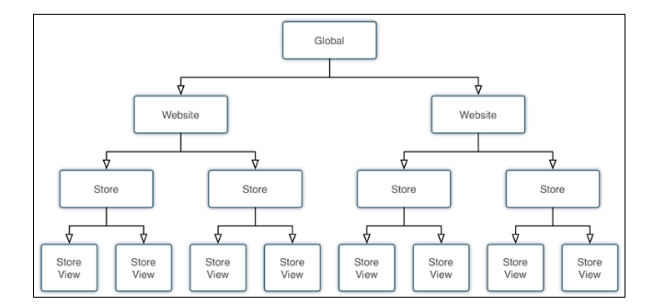

## **Scenario**: Global Multi-Store website manage a range of stores at the same time. Consider a brand of garments / apparels of one brand, which is offering both male and female clothing.

## You can have two separate sites for women and men respectively with only one admin interface to control two stores.

## In Front-end specific components like categories and product displays is possible only from the stores.

## The Store reflects a real shop with all offered products and services well described.

## Add attributes like check-in, check-out, selective pricing, and add to cart option are all included.

## In same log-in to admin panels of each website to track purchases and customer behaviour. You receive a total control of all your online stores under different domain names and IP addresses.

**Steps to perform multi-store view**

1. Log-in to your Magento admin panel.
2. Find the Catalog tab where you need to select Categories.
3. Click on the Add Root Category button placed on the left.
4. It’s recommended to enter your title (i.e. Shoes.com) on the right where it says Name. Set Yes for both enable category, Include in menu and (Display Settings) Anchor.
5. Press on the Save Category button.
6. Move on to the Stores menu and choose All Stores.
7. Click on the Create Website button.
8. You have to insert Shoes.com for the Name once again; for the Code, you simply enter word shoes. Keep this value in mind for the future.
9. Press Save Website.
10. Click on the Create Store button.
11. For the Website, pick Shoes.com from the dropdown menu. For the Name, enter Main Store. Code (Let Say 01_shoes). For the Root Category, select the Shoes.com from the dropdown once more.
12. Click on the Save Store button.
13. Click on the Create Store View after.
14. For the Store, pick Main Store from the dropdown menu, but make sure it’s exactly for the Shoes.com website. For the Name, enter English. For the Code, put in shoes_en. For the Status, select Enabled from the dropdown.
15. Click the Save Store View button.
16. Move to the store menu and select Configuration.
17. For the Current Configuration Scope (it’s on the top left), change the dropdown from Default Config to Shoes.com.
18. Select Web from the sidebar on the left under the General heading.
19. For both the Unsecure and Secure sections [Base URLs and Base URLs (secure)], uncheck the Use default box next to the Base URL item, and enter the URL for your store, e.g. http://www.shoes.com/. Don’t forget the trailing slash!
20. Click the Save Config button.

21. Go to store -> configuration->General settings. Change Country option, Local Options as per the need. Don't Change Store Information.

22. Create same for another language. Click to Dashboard and select language wise store view

http://docs.magento.com/m2/ce/user_guide/catalog/product-types.html

## Task 2: Managing Products in Magento 2

Magento has **six product** types in the default community edition and a **seventh Gift Card** option in the Enterprise edition. You can simply add a product by clicking the arrow next to the add product orange button and selecting the appropriate product type.

### **Simple Products**

Simple products are the staple of any Magento site and make up Configurable, Grouped, and Bundled products that you might also use in your store. Simple products are typically used for selling basic products like a widget with no size or color options. It can be used as part of a configurable product to make a widget with size and color options.

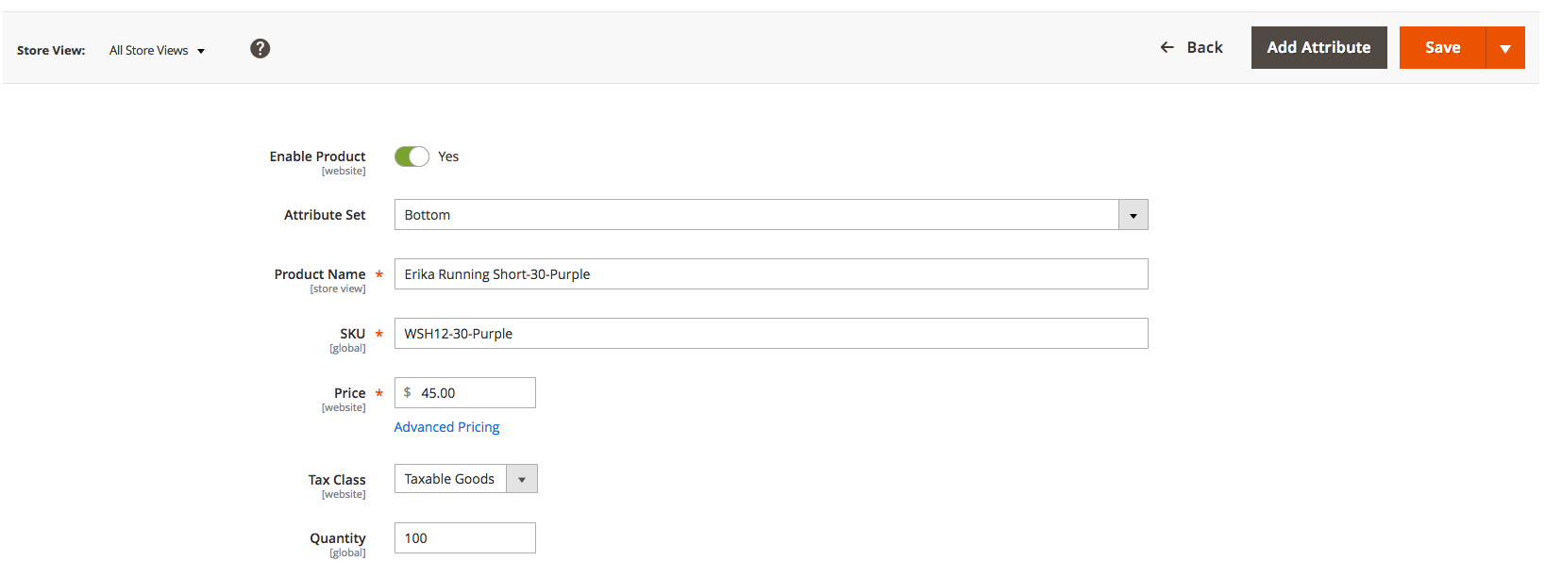

 You can, however, create simple product customizable options to offer things like size and color, but you will only be able to control the title of the option, price, and **SKU (Stock Keeping Unit).** So, if you need to change the weight or inventory of the options you cannot do that and will most likely want to use configurable products.

One of the cool things about Magento 2 is that you can actually change a simple product into a **configurable product in the configurations section:**

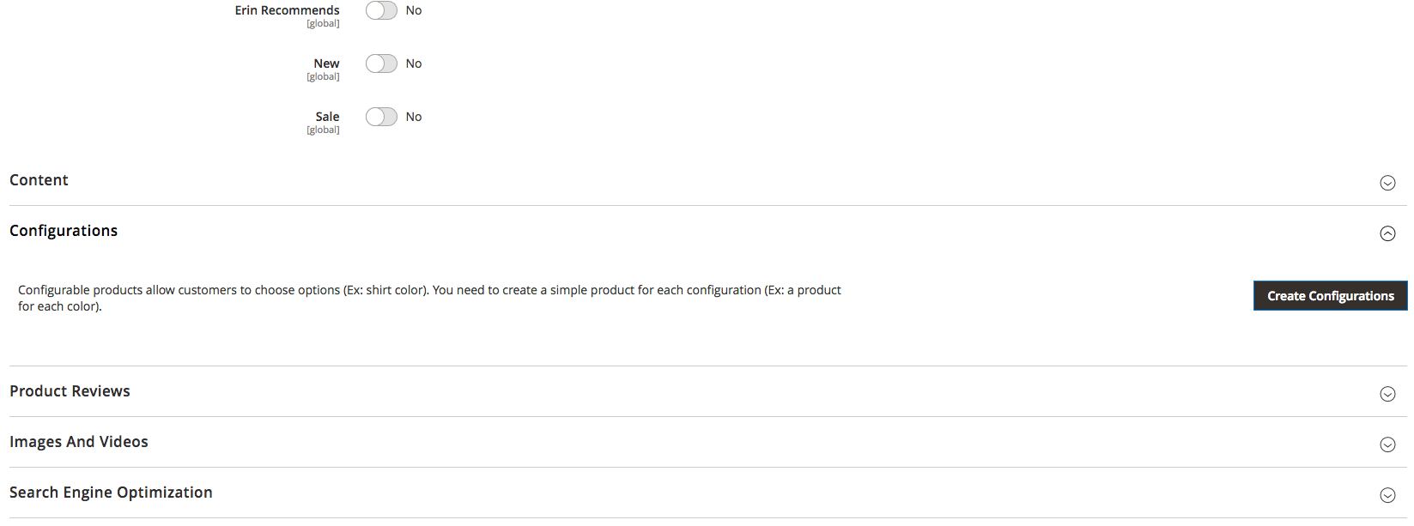

1. **Configurable Products**

Configurable products are the main SKU that has variable options like size, color, or style. Each option within the configurable product has to be its own simple product. Therefore a configurable product with red green and blue options must have three simple products associated with the configurable product. You can see what this would look like here:

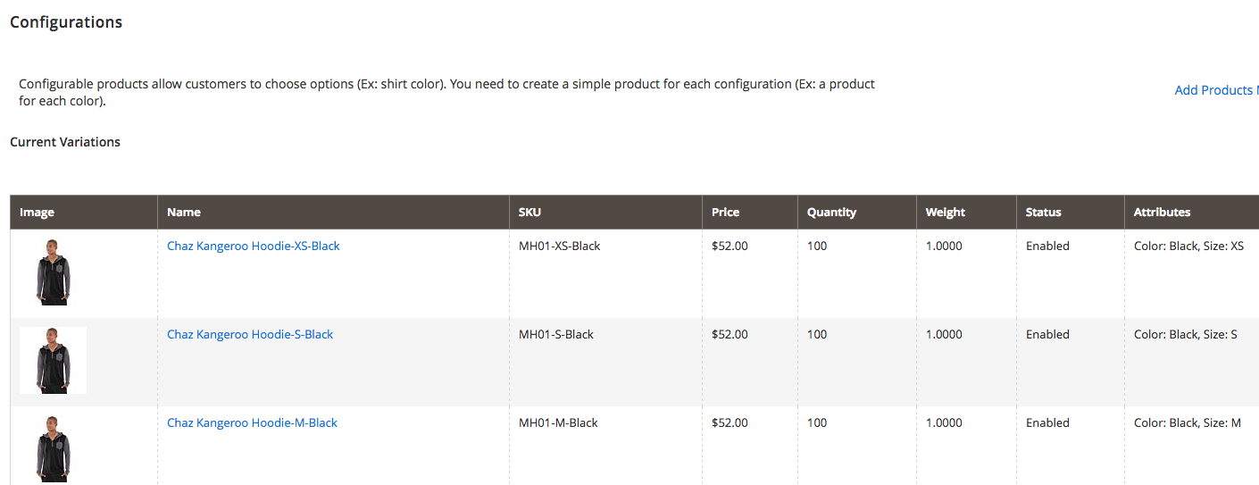

**3. Grouped Products**

Grouped products can easily be confused with a configurable or bundled product. However, a grouped product is meant to be a collection of individual products that make up one product like a furniture set or beer making kit. You could buy each product individually, however, a grouped product might be a better deal as you are buying them all together as one product.

Just like a configurable product you need to create the individual products as simple products and associate them all with the main grouped product that will be a collection of all those simple products. This is an example of a set of sprite straps as a grouped product.

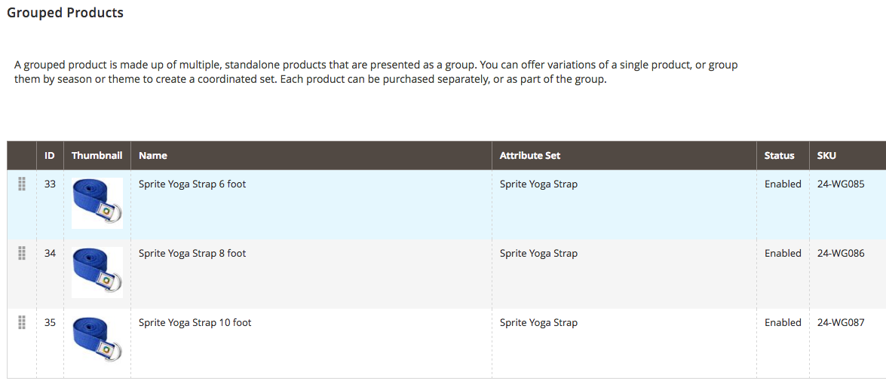

### **Bundled Products**

A bundled product is different from a grouped product in that it is its own product in itself, not just a group of products that make it a collection or group. A bundled product is most similar to a laptop, or complex product with many different individual and customizable options that could be their own standalone product like different processors, RAM, and hard drives. However, the bundled product itself is a complete product made up of many individual simple products like a computer made up of computer parts.

A bundled product, just like configurable and grouped, requires all the simple products to be created individually and associated with the bundle as you can see here:

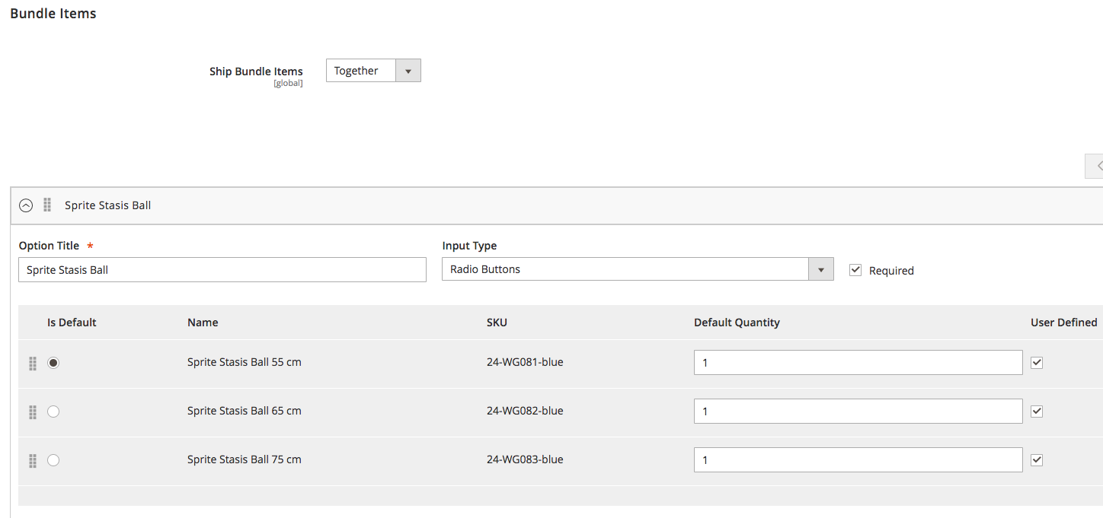

1. **Virtual Products**

Virtual products are essentially the same thing as simple products except they are meant for non-physical products that are not downloadable like a warranty or some other type of service you might be buying online. There is no weight by default because it is a virtual product.

1. **Downloadable Products**

Downloadable products are products meant for downloads like the digital downloads Embroidery site Designs By JuJu we built on Magento. If you want to sell eBooks, digital downloads, or any other type of downloadable product, this is a great way to do it.

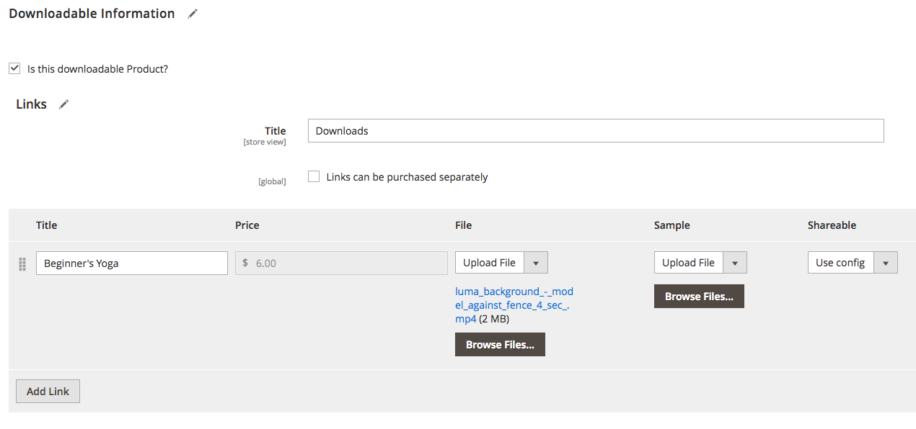

**7. Gift Cards (Enterprise Only)**

Gift cards are exactly what you think and are an enterprise feature you can use to create either physical or non-physical gift cards for customers. You can choose the amount and other parameters to create different kinds of gift cards for different purposes.

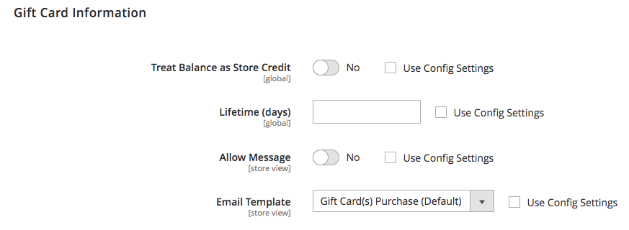

**Task 3: Display list of attributes for any product**

**Attributes**

Products by default will come with about 40 attributes you can fill out like

* **SKU, Price, Product Name, Description, etc**.

You can add additional attributes to a product via adding new attributes and adding those attributes to the attribute set associated with the product.

Some attributes will be setup as required but most will be optional attributes that can be leveraged by products you want to use with. Attributes have many different options and input types you can leverage for various types of data you want to add to a product or collection of products.

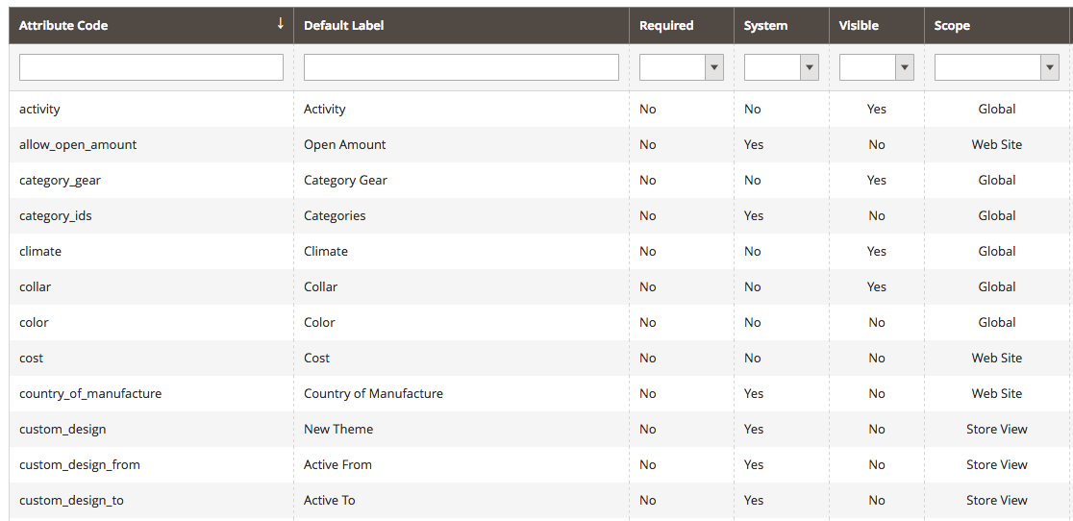

**Attribute Sets**

Every product must have an attribute set, and often times companies just use the default attribute set for all their products. However, if you have a large or complex catalog, attribute sets can allow you to create different sets of attributes that can be used for different types of products. That way products that only need 30 or so attributes won’t be overloaded with hundreds of attributes that may be other types of products might need.

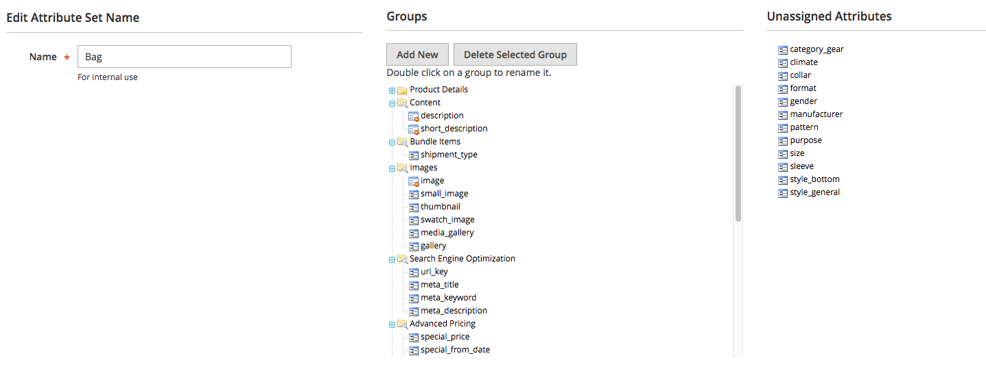

**Task 4:** **Export the products list in a csv file. Update product information, import the same file, and show changes is website. Add a new product inside a category in the same csv file and update in website.**

### **Exporting and Importing Products**

Exporting and importing products is an incredibly useful feature of Magento. It can allow you bulk delete products, add a lot of new products quickly, or update a large amount of product information quickly as well.

You can import products as add or update which either adds new products or updates existing products, replace products or deletes products in the import.

You can export products and select which attributes you don’t want to export to reduce the export product file.

One of the best ways to import products is to create some manually the way you want them structured and export them and follow that file format so you are following the correct import file structure.

Import and Export of products can be found in **System => Data Transfer => Import or Export**

##### **Task 5: Related Products, Up-Sells, and Cross-Sells**

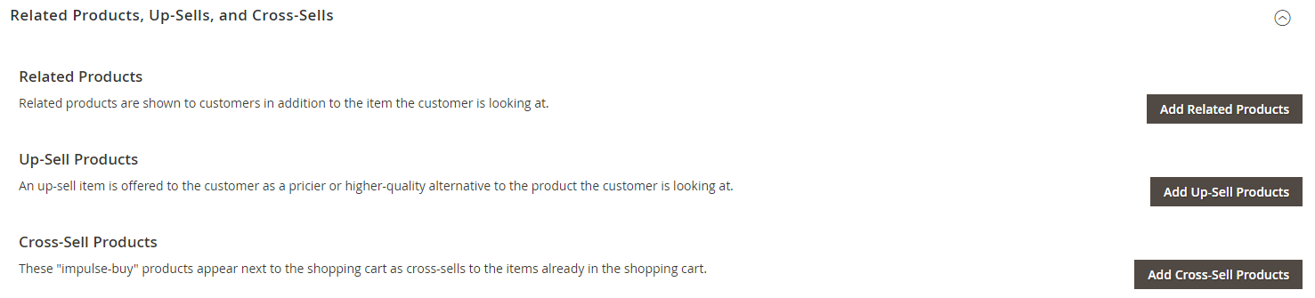This section is used to set up simple promotional blocks that present a selection of additional products that might be of interest to the customer.

#### **Product Relationships**

Products in your catalog can be promoted on other pages by defining the nature of the relationship between the products. The options available are:

* Related products
* Up-sell products
* Cross-sell products

**Related Products**

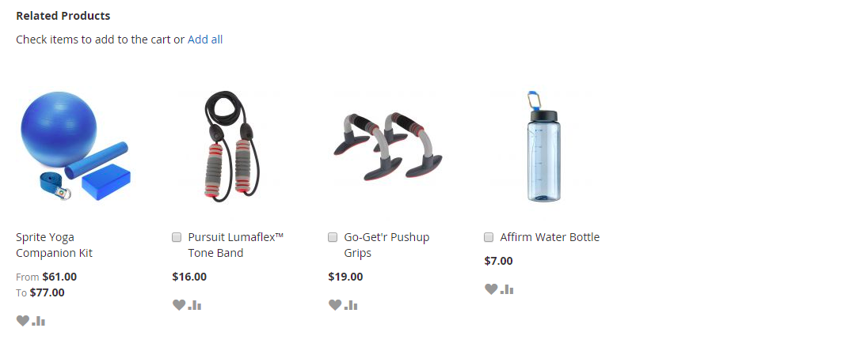Related products are meant to be purchased in addition to the item the customer is viewing. They complement, enhance, or add optional features to the product.

*To set up related products:*

1. Open the product in edit mode.
2. Scroll down and **expand** the Related Products, Up-Sells, and Cross-Sells section. Then, tap Add Related Products.
3. Use the **filter controls** to find the products that you want.
4. In the list, mark the checkbox of any product you want to feature as a related product.
5. When complete, tap Add Selected Products .

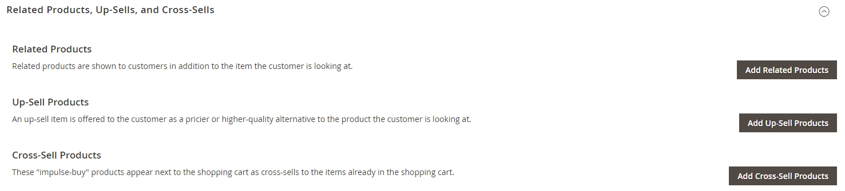

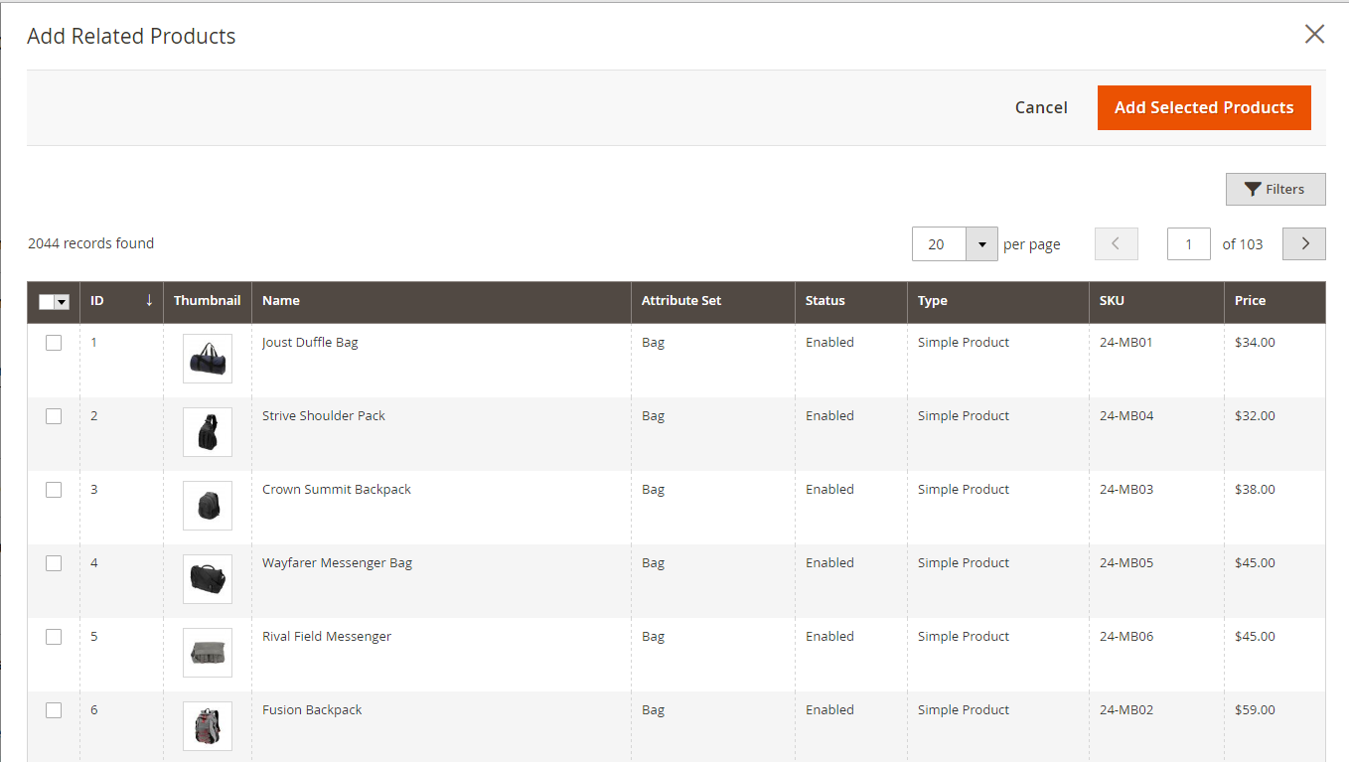

[**Up-sells**](http://docs.magento.com/m2/ce/user_guide/catalog/settings-advanced-up-sells.html)

Up-sell products are items that are similar, but are perhaps of a higher-quality, more popular, or have a better profit margin than the item the customer is considering.

*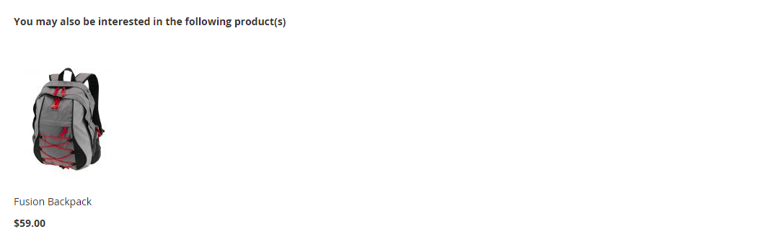To select up-sell products*:

1. Open the product in edit mode.
2. Scroll down and expand the Related Products, Up-Sells, and Cross-Sells section. Then, tap Add Up-Sell Products.
3. Use the **filter controls (*)** to find the products that you want.
4. In the list, mark the checkbox of any product you want to feature as an up-sell product.
5. When complete, tap Add Selected Products.

**(*)**[**To filter the list:**](javascript:void(0);)

1. Tap **Filters**.

2. Complete as many filters as necessary to describe the record you want to find.

3. Tap **Apply Filters**.

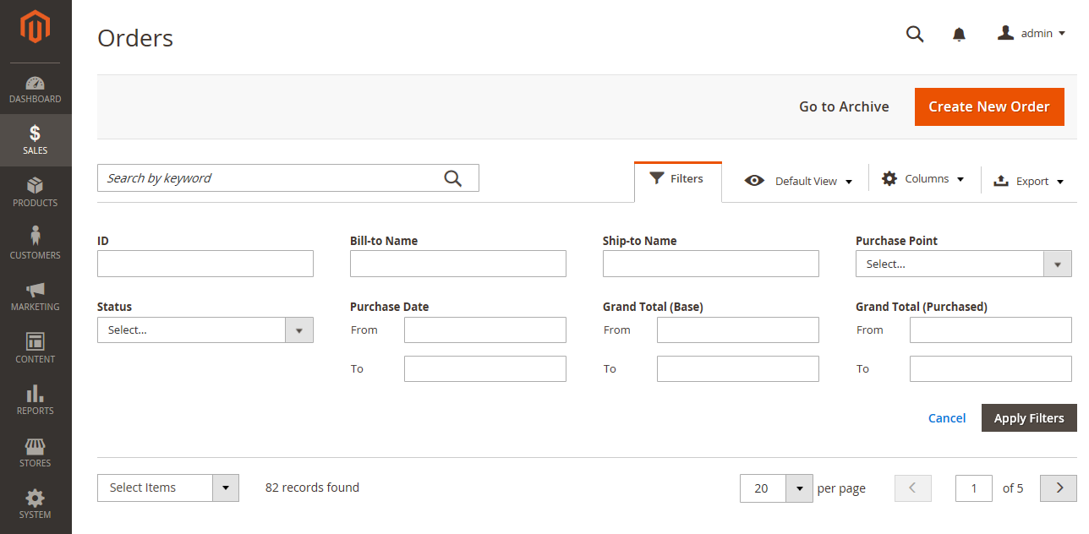



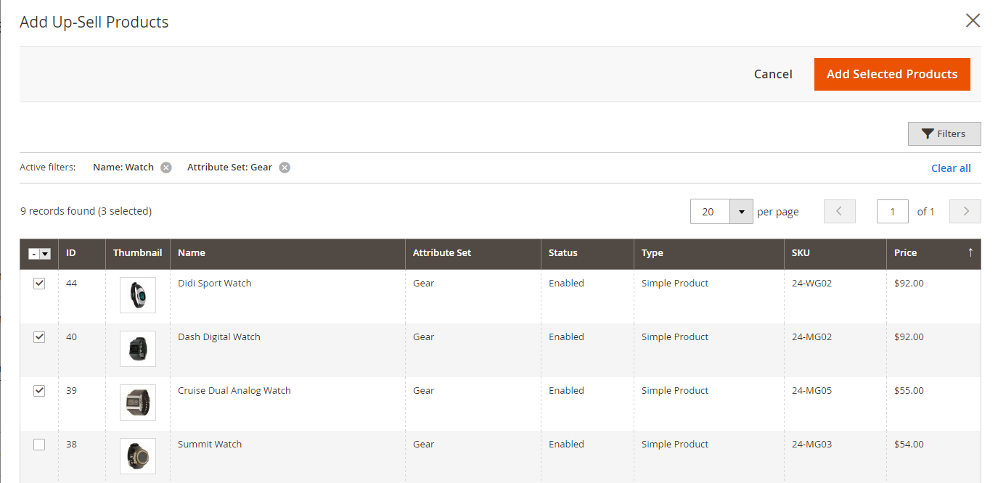

[**Cross-sells**](http://docs.magento.com/m2/ce/user_guide/catalog/settings-advanced-cross-sells.html)

Cross-sell products are offered on the shopping cart page as last-minute purchases before the checkout process begins. Cross-sell items are similar to impulse purchases positioned next to the cash register in the checkout line.

Products offered as a cross-sell appear on the [shopping cart](javascript:void(0);) page, just before the customer begins the [checkout process](javascript:void(0);).

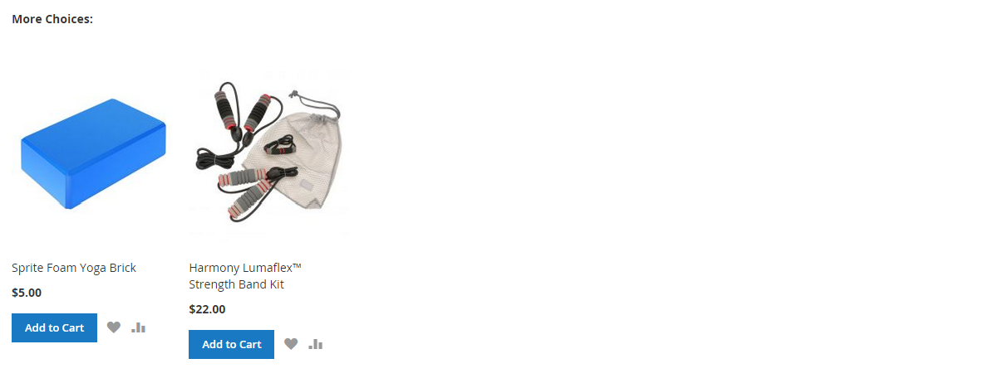  
**Cross-sells in Shopping Cart**

*To select cross-sell products:*

1. Open the product in edit mode.
2. Scroll down and expand the Related Products, Up-Sells, and Cross-Sells section. Then, tap Add Cross-Sell Products.
3. Use the **filter controls** to find the products that you want.
4. In the list, mark the checkbox of any product you want to feature as a cross-sell product.
5. When complete, tap Add Selected Products.



|  |  |  |
| --- | --- | --- |
|  |  | |
|  |  |

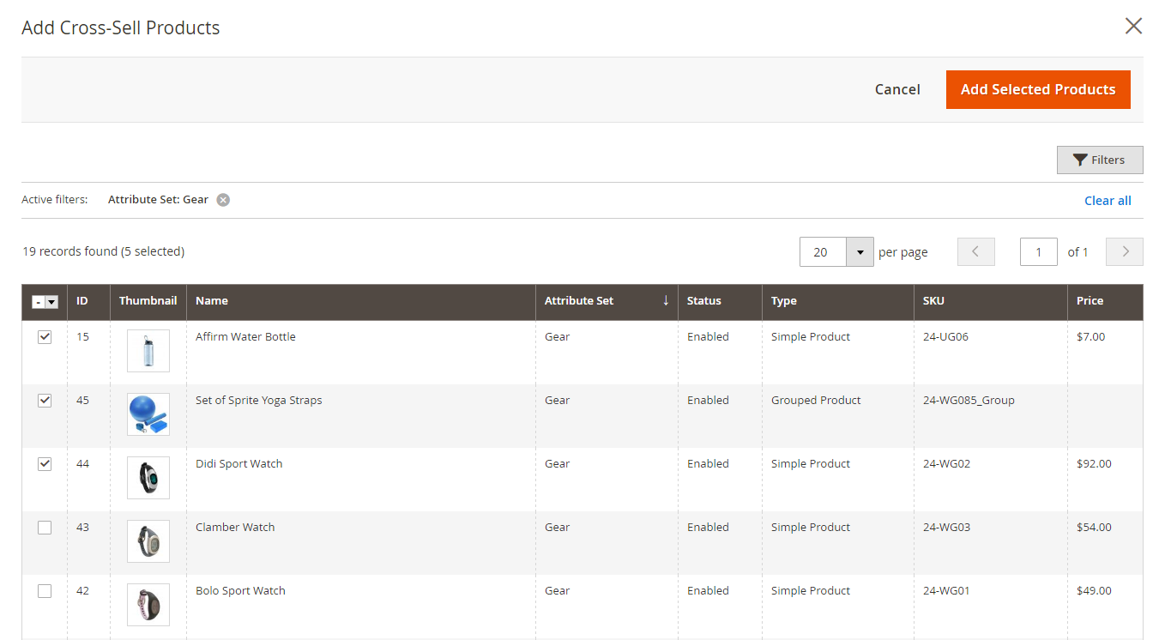  
**Cross-sell Products**